Nexora portal management
Document 26 of the Nexora learning guides
Source snapshot 13 October 2026 at 17:12 UTC
Understand CRM control of member portal branding, themes, menus, pages and onboarding.

Recognise the screen and its scope
Open /portal-management. CRM routes use port 3017; member routes use 3018; public website routes can use 3019. Brackets name a route parameter, not text to paste into a browser. Choose a real record or site id from the application.
This guide covers Draft save preview and publish; Portal name tagline and welcome; Neon and classic appearance controls; Motion settings and reduced motion; Menu labels order and visibility; Dashboard sections and custom pages; Self-registration and organisation-request settings.
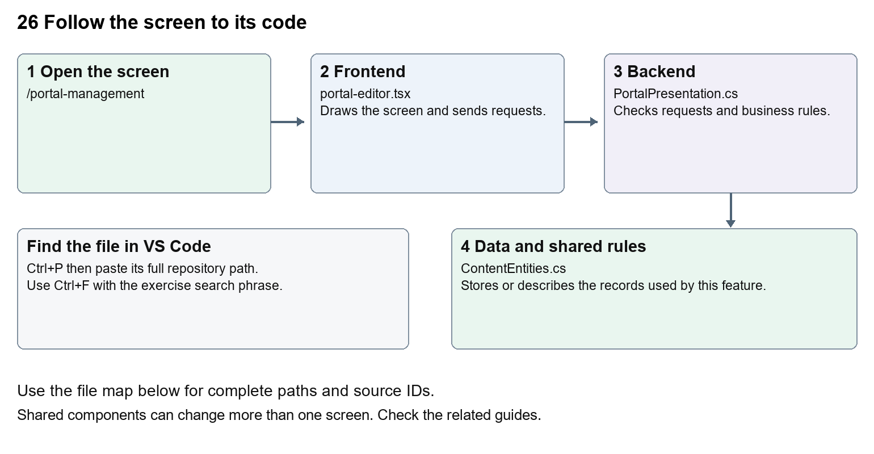
The diagram shows the file roles. The full paths below are what you paste into Ctrl+P.

Find the files in VS Code
Role | File and source ID | What it does
Screen | S0067 portal-editor.tsx | Main UI or route for this topic
Server | S0235 PortalPresentation.cs | Endpoints or server rules
Data | S0216 ContentEntities.cs | Data shape or persistence structure

Screen S0067
apps/web/src/features/content/portal-editor.tsx
Server S0235
backend/src/Modules/Nexora.Modules.Content/PortalPresentation.cs
Data S0216
backend/src/Modules/Nexora.Modules.Content/ContentEntities.cs
The complete HTML manual opens these source IDs inside its Source library. The Word manual shows short labelled extracts so you can learn the flow before reading large files. Each individual Markdown guide includes its complete primary files after the walkthrough.

Follow the request and the records
1. PortalEditor loads the draft and published configuration.
2. Staff change draft fields and preview the appearance.
3. Saving persists a draft with its expected version.
4. Publishing validates and replaces the published configuration.
5. Member and public sign-in views read the published settings for the association.

Read the code with an explanation
Draft and published settings are separate. The preview shows presentation while member data stays live in the real portal. Labels and page text are stored data, so administrators can change them without coding. presentation.ts supplies fallback defaults; changing a fallback does not overwrite an existing published configuration. Dashboard stays available even if other menu links are hidden.
Source reference S0067 apps/web/src/features/content/portal-editor.tsx
Selected opening lines with their original numbers. The complete file is in the HTML source library.
0001 "use client";
0002 import { WorkspaceHeading } from "@/components/ui/workspace-heading";
0003 import { RecordListing } from "../shared/record-listing";
0004 import { useEntityListing } from "../shared/entity-listing-controls";
0005 import listingStyles from "../crm/record-listing.module.css";
0006 import { ArrowLeft, Plus } from "lucide-react";

The import lines lead to shared components and helpers. Start at the exported component or route function; follow the request helper to the server rather than assuming the whole feature lives in this file.
Source reference S0235 backend/src/Modules/Nexora.Modules.Content/PortalPresentation.cs
Extract from source line 73. A fragment from a long line is shown without the rest of that line.
0073 api.MapGet("/portal", async (ContentDbContext db, CancellationToken ct) => Results.Ok(ReadPortalConfiguration(await db.Set<PortalConfiguration>().SingleOrDefaultAsync(ct))));

On the server, look for MapGet to load records, MapPost to create or perform an action, MapPut or MapPatch to change data, and RequireAuthorization for permissions. Some shared methods register endpoints indirectly. Find SaveChangesAsync to see the database write. A request method alone does not tell you every side effect.
Source reference S0216 backend/src/Modules/Nexora.Modules.Content/ContentEntities.cs
Selected opening lines with their original numbers. The complete file is in the HTML source library.
0001 using Nexora.BuildingBlocks.Domain;
0003 namespace Nexora.Modules.Content;
0005 public sealed class Site : TenantEntity
0006 {
0007 public string Name { get; set; } = "";
0008 public string Tagline { get; set; } = "";

Follow model fields to their request names and database mapping. An id points to a particular record. A tenant id limits the organisation. A version or concurrency stamp protects newer edits. Some model files describe contracts rather than tables; check the owning DbContext before assuming storage.

Make or trace your first change
1. Press Ctrl+P and open apps/web/src/features/content/portal-editor.tsx.
2. Press Ctrl+F and search for Branding and welcome. In this snapshot it appears at line 57.
3. Replace this editor section heading only. Open Portal management and inspect Settings. For a no-code exercise, preview a changed draft welcome message, then discard it rather than publishing to members.
4. Replace only Branding and welcome with Portal branding and welcome in that intended location. Keep quotes, tags, JSON keys and routes intact.
5. Save with Ctrl+S. Inspect Problems and the local screen. Review the diff and restore the original text when you finish practising.
Extract from source line 57. A fragment from a long line is shown without the rest of that line.
0057 xt-xl font-semibold sm:col-span-2">Branding and welcome</h2>{([['name', 'Portal name', 100], ['tagli

These exercises have not been applied to the application. Their search phrases are verified against the captured source. Line numbers can move; the phrase and file path are your main navigation aids.

Check a change and diagnose problems
Confirm the original screen still loads, the changed words appear in the intended place, and another screen using the same component still behaves correctly. If an action fails, inspect the browser Network response, the relevant helper and server validation message. Use the common error table at the beginning of the manual. Reload on a version conflict instead of removing the version check.
A syntax error after a text edit usually means a quote, brace or closing tag changed. Compare your diff with the original. An unchanged browser result can mean the wrong port, a saved published configuration overriding a default, or a running API that has not reloaded.

Understand the current limits
Editing needs content.manage and publication needs content.publish. Custom member pages are plain text, not arbitrary executable HTML. Published onboarding changes can allow new registrations.

Continue learning
Related guides 24 Nexora member portal login and onboarding, 25 Nexora member portal journeys, 27 Nexora website editor and publishing.

